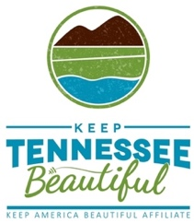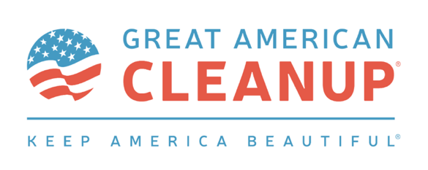
For Immediate Release: March 1, 2024
Contact: Cindy Dupree Holloway
Cindybdupree@gmail.com
615-838-9616

JUDGE BLAKE ANDERSON RECEIVES
2024 LEADER AGAINST LITTER AWARD
Executive Director Missy Marshall, Keep Tennessee Beautiful, Makes Presentation

MEMPHIS, Tenn. (March 1, 2024) – Environmental Court Judge Blake Anderson, Jackson, Tenn., was honored today with Keep Tennessee Beautiful’s prestigious Leader Against Litter Award. KTnB Executive Director Missy Marshall made the presentation during the 2024 Keep Tennessee Beautiful Month and Great American Cleanup Kick-off held at Conservation Hall at the Tennessee Governor’s Residence in Nashville.

“I’m humbled and grateful for this special award from Keep Tennessee Beautiful,” Judge Anderson said. “I love our state and believe if everyone works together we can protect our environment and help make a difference where we live.”
Judge Anderson spends time outside of his Criminal Court, presiding over one of only seven Environmental Courts in the State of Tennessee. A long time advocate for the city of Jackson, Judge Anderson assisted in getting the city’s first-ever litter/illegal dumping ordinance, and became a vocal supporter of the new litter camera program and anti-litter initiatives. Judge Anderson also spearheaded a community service cleanup program for offenders, in lieu of jail sentences.
“Judge Blake Anderson truly cares about the environment, and leads his entire community by example,” Marshall said. “Not only does Judge Anderson oversee the Environmental Court in Jackson, he also spends much of his free time volunteering at cleanup and beautification events. Judge Anderson is making a difference where he lives by helping keep Jackson clean and beautiful.”

Nominees for the prestigious Leader Against Litter Award were submitted from statewide Keep Tennessee Beautiful affiliates. Criteria required nominees be elected officials and an “environmental hero.” All submissions included examples of how each leader went above and beyond their job description to involve citizens in environmental improvements.

Keep Tennessee Beautiful Month and the Great American Cleanup help accomplish the mission of KTnB: to educate and inspire Tennesseans to take action every day to improve and beautify their community environment. Commissioner Mark Ezell, Tennessee Department of Tourist Development, brought the keynote address at the kick-off event.

View the Facebook event page here: URL TBD
View Judge Blake Anderson’s Video: URL TBD
For more information, visit https://www.keeptnbeautiful.org/
###
About Keep Tennessee Beautiful:
Keep Tennessee Beautiful is the state level affiliate of Keep America Beautiful and serves as a state resource for litter prevention, community greening, and recycling and waste reduction education.

Keep Tennessee Beautiful is a grant-funded organization sponsored by the Tennessee Department of Transportation as a community engagement program at The University of Memphis – Center for Regional Economic Enrichment.

